FitGuide AI Agent Project Submission
Course: ITAI 2376 – Deep Learning
Project: FitGuide AI Fitness & Nutrition Agent

Group Members
- Tien Manh Nguyen
- Oman Malek
- Lufei Yu
- Phillip Torres

GitHub Repository

https://github.com/mnn6789CyberAIBlockchain/TienManhNguyen_GROUP4_ITAI2376.git

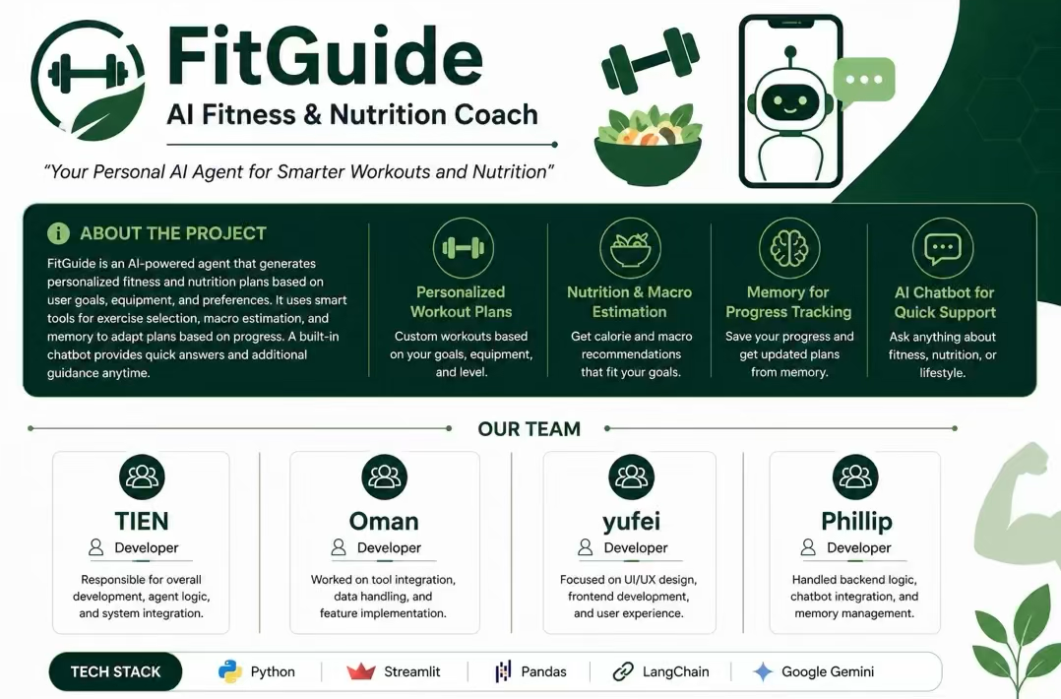
Demo Video

